|  |  |  |
| --- | --- | --- |
| STANDARD OPERATING PROCEDURE OF FILLING THE WEEKLY SHIFT DATA FOR THE FRONT OF THE HOUSE | File No. | BV-OP-P&P-001-01 |
| Effective Date | 2018 June 13, 2018 |
| REVISION DATE |  |  |
| APPROVED BY |  |  |

1. **目的Purpose**

To ensure that each employee know about all the high-level of group company, when the group come to Bella Vita, all employees(including Hall and Kitchen staff) must be well prepared, show the best quality and best service to them.

确保每位员工知道集团公司的所有高层，当集团公司高层前来用餐时，从前厅到厨房所有员工必须做好充足准备，体现出最好的质素以及最优秀的服务。

**2. 程序/步骤Procedures**

1. Completed in the orientation training of first day

第一天入职培训中完成

1. Introduce the subordinate relationship between RDM & Florentia Village and Bella Vita

介绍RDM集团公司以及佛罗伦斯小镇和Bella Vita的从属关系

1. Display the top level of group company to new employees, as well as relevant matters needing attention. (e.g. personal dining preference, etc.)

展示集团公司高层领导的头像给新入职员工，以及相关注意事项。（如个人用餐偏好等。）

1. Test cognitive level of employees in the training. If the employees fail the test, continue the training until cognition is achieved thoroughly.

测试员工的认知程度，如不能通过测试，则继续培训直到彻底认知。

1. **标准图样Standard Samples**

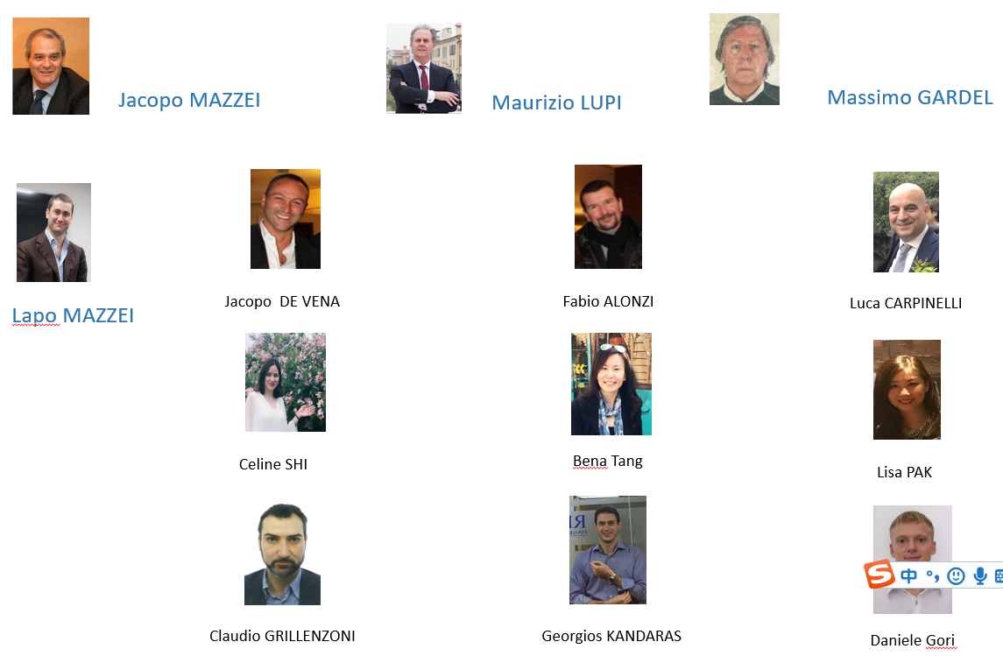

1. **注意事项 Notes**

意桥食博餐饮管理（天津）有限公司保留对本文件的最终解释及修正权；未经公司批准,禁止复制、泄露和使用。

Ponte Vecchio Italian Cuisine & Wine bar Management (Tianjin) Co., Ltd. may at its sole discretion amend part or all of this policy. Reproduction, disclosure and using without company’s approval shall not be allowed.